

Multi-Factor Authentication Enrollment process Job Aid and early adopters instructions

March 2019

Contents

1. Introduction
2. PingID enrollment steps
3. You will find the PingID enrollment steps in English, Spanish, Chinese,French, German, Portuguese,Japan, Russian, Italian and English.

Introduction
This document provides steps to set up PingID for the first time and how to pair your desktop computer, mobile device, Voice or SMS, with your current P&G credentials.

To learn more about PingID and why P&G is implementing this additional security layer, click here.

English Version:

PingId enrollment steps
Please follow below steps to correctly enroll in the PingId program.

Step 1
Go to http://ping.pg.com/ and login with your P&G Intranet ID and password, then read STEP 2 before proceeding further.

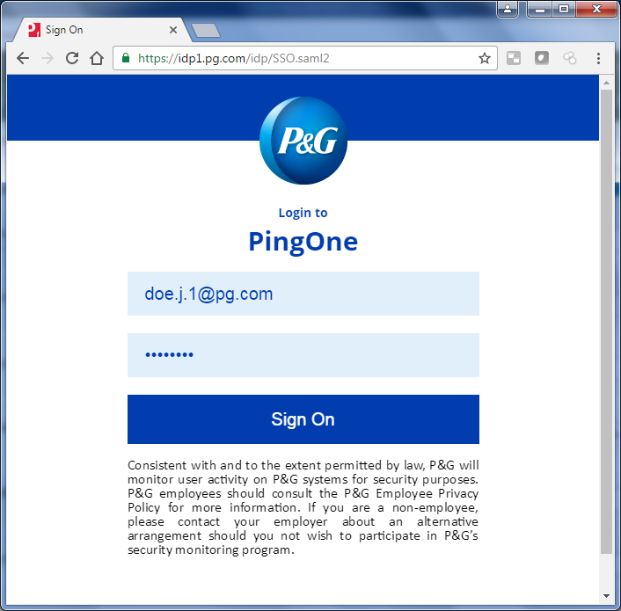

Step 2
PingID allows you to authenticate into P&G applications using your username (doe.j.1) and Intranet Password, plus a mandatory additional factor for security.
It's highly recommended that you install / enable 2 or more options, so that you can authenticate if your primary device is not available. The recommended 2 options are: Desktop applicalton (PC/Mac) + Mobile application, OR Desktop application (PC/Mac) + Mobile SMS text message.
To start the device installations, Click Continue and follow the next instructions.
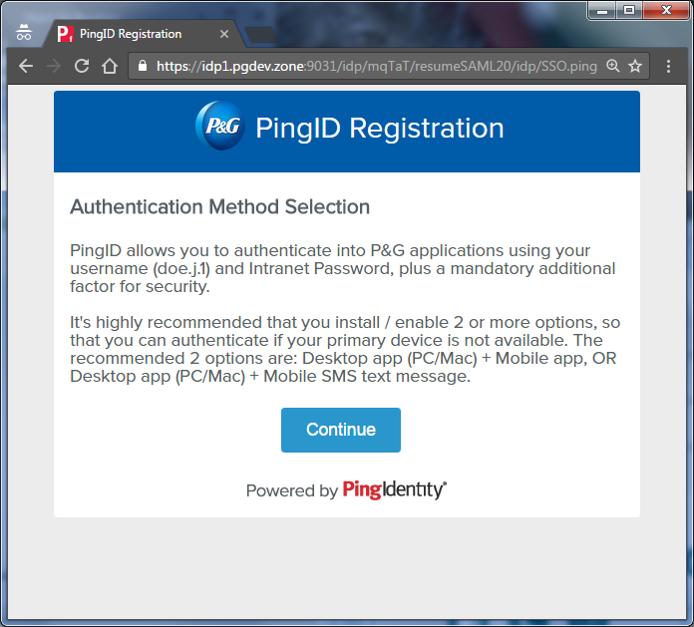
Step 3
Authentication Method Selection  Select the option you want to configure for use during authentication:  · Desktop Application  · Mobile Application  · SMS/Texting  · Voice | 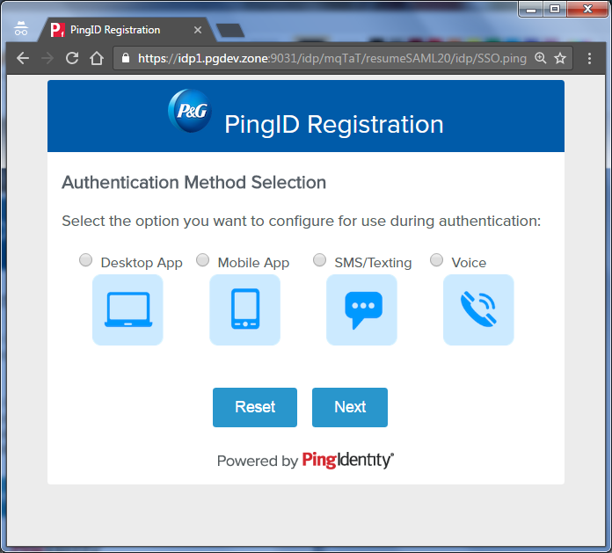
SMS/Texting  SMS delivers a text message to a mobile phone with a 6-digit authentication code as part of the sign-in process. Register a mobile device as a backup option in case your primary device is not available.  1. In the PingID Registration window select the option “SMS/Texting”  2. Choose your country code and enter your mobile phone number.  3. Verify the number before clicking “Next”.  4. Click Next. | 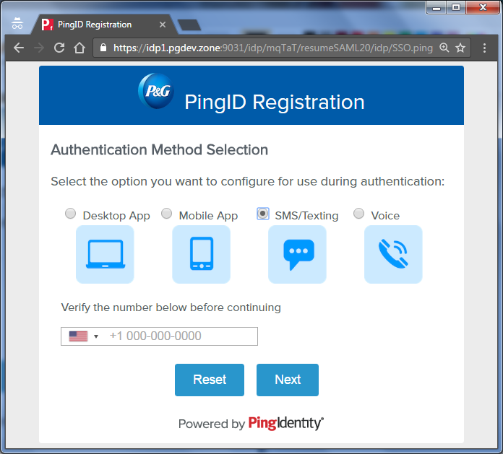
5. Enter into the PingID Registration window the registration code that was received via SMS and Click Next.  6. If you want to add another Authentication Method, mark the selection and click Register Another. If not, just click on Finish Registration to complete the process. | 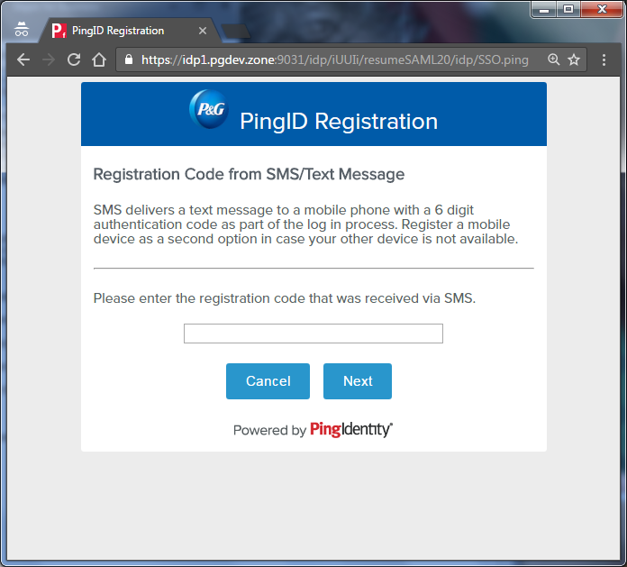
Voice  1. In the PingID Registration window, select the option “Voice”  2. Choose your country code and enter your phone number.  3. Verify the number before clicking 'Next'.  4. Click Next. | 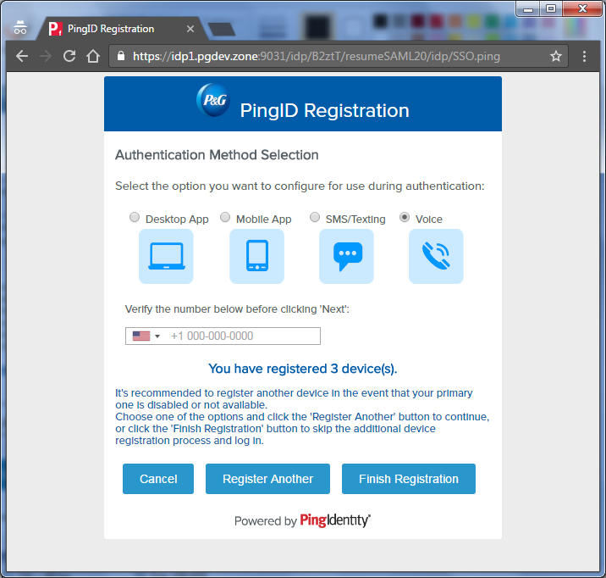
5. You are going to receive a voice call that will give you the number you need to type into the registration code field. Enter it and click Next.  6. If you want to add another Authentication Method, mark the selection and click Register Another. If not, just click on Finish Registration to complete the process. | 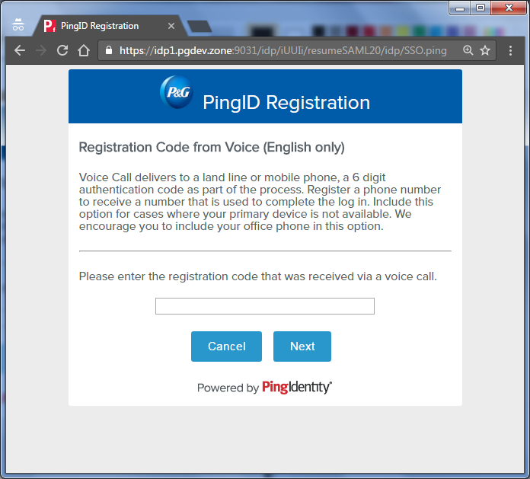
Mobile Application
- In the PingID Registration window, select the option “Mobile App”
- Then Click next.
- Install the Ping Mobile Application from your mobile store.

- To complete the pairing, start the PingID application on your mobile device and complete one of the following options to copy the Pairing Key provided in the PingID Registration Window:  - Scan the QR code shown on the screen by framing it within the scanning window of the application  - Click the button on your mobile device that allows you to manually enter the 10-digit pairing code shown on the screen.  - If you want to add another option, mark the selection and click Register Another. If not, just click on Finish Registration to complete the process. |  | 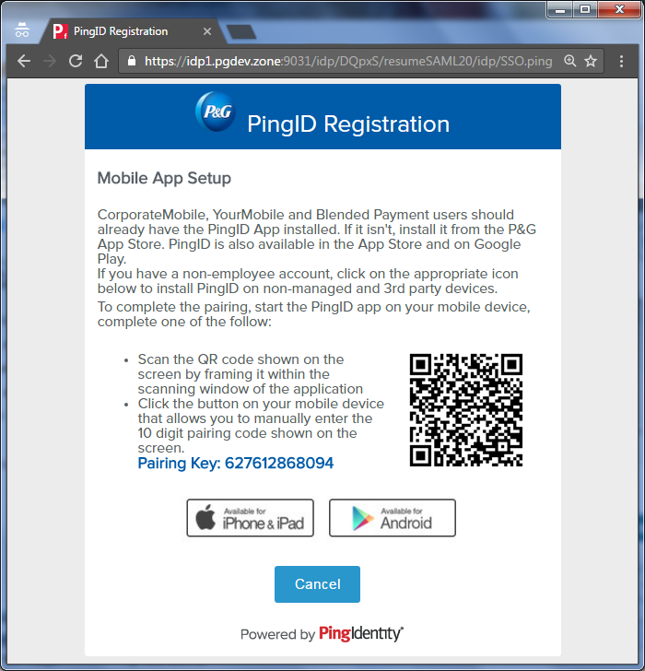
Manage Devices and update your PING account.
Sign in on this link http://ping.pg.com/ to update your account. You should see the list of devices you have paired.
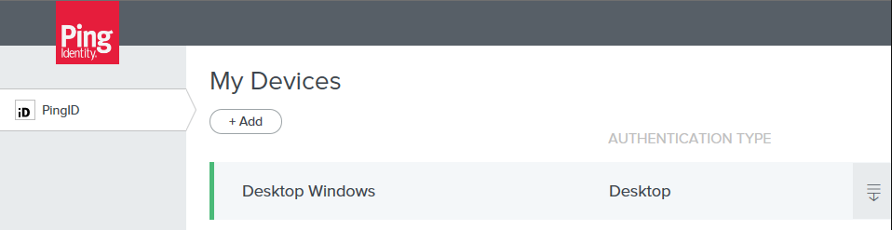
If you only see one device, you should add a secondary authentication form on a different device by clicking "Add" and follow the prompts. For example, if you have a corporate mobile device (i.e. CorporateMobile, YourMobile, Blended Payment), you can use your personal device for authentication (SMS, phone call, or Mobile application). You can also include your office phone as a Voice option.
Remember that you can go to http://ping.pg.com/ to access your dashboard whenever you want to add, modify or delete the devices paired with your account.
You are done! Ongoing, you will login with your P&G credentials, as well as your chosen PingID authentication method when using cloud-based services including Email, OneDrive, Yammer, Office Online, etc.

You can find the PingID steps in the following local languages:
Spanish Language
Chinese Language
French Language
German Language
Portuguese Language
Japan Language
Russian Language
Italian Language
English Language

