|  |
| --- |
| **P&G Taiwan Invoice instruction** |

**第一部份：發票細節 (Invoice instruction)**

***應該如何呈現發票內容? (Invoice content highlight)***

* ***發票抬頭/統編/地址(Bill to data)***

|  |  |  |  |
| --- | --- | --- | --- |
| **LE** | **統編**  **GUI tax no** | **發票抬頭**  **Bill to Company Name** | **發票地址 (同郵寄地址)**  **Bill(mailing) to address** |
| 438 | 21238199 | Procter & Gamble Taiwan, Ltd.  寶僑家品股份有限公司 | 7F, no 106, Xin Yi Road, section 5, 110, Taipei, Taiwan  台北市信義路五段106號7樓 |
| 2355 | **54645014** | Procter & Gamble Taiwan Sales Company Limited  台灣寶潔股份有限公司 |

* ***該將發票寄送到哪裡給誰? Where/whom to submit invoice?***
* 所有發票 (及其相關文件) 應當直接寄到以下的郵寄地址, 請 勿寄送至其他部門人員,以免發票遺失或付款延遲:
* Please send invoice (and supporting) directly to below, and don’t send to any other P&G contact to avoid invoice lost or delay payment.

**收件人:** 寶僑家品股份有限公司 Procter & Gamble Taiwan Ltd.

財務部應付帳款部 余思穎小姐收 Attention: Finance Account Payable Ms. Jennifer Yu

**住 址:** 台北市110信義路五段106號7樓 7F, No, 106, Xin Yi Rd, section 5, 110,Taipei, Taiwan

or

**收件人:** 台灣寶潔股份有限公司 Procter & Gamble Taiwan Sales Company Limited

財務部應付帳款部 余思穎小姐收 Attention: Finance Account Payable Ms. Jennifer Yu

**住 址:** 台北市110信義路五段106號7樓 7F, No, 106, Xin Yi Rd, section 5, 110,Taipei, Taiwan

* **重要的發票細節 To ensure timely process your payment, pls ensure invoice meet as below request:**

為確保能夠準時付款，供應商或廠商應當提供完整的發票，必須含有所有適當的內容以完成順利的作業程序：

* 有採購訂單(PURCHASE ORDERS)的請款型式，必須依以下條件提供必要之單據: (With PURCHASE ORDERS)
* 您的公司名稱, 地址, 等等…Your company name/ address/ contact detail (contact person /tel / fax

/ email...)

* 你的發票號碼 Invoice reference number
* P&G公司名/發票地址/統編**:** Correct P&G bill to data (data as above mentioned)
* 發起人/P&G 聯絡人名字/ 姓/ 所屬部門 P&G contact name/ department
* 採購訂單號碼 (Purchase Order (PO)number)
* 簽收單號碼 (Goods Receipt (GR) number)
* *金額* – 必須完全與採購訂單(PO)上的金額相同。為避免付款的延遲發生，所有不符合的內容都要在開發票之前先與採購聯絡並解決 (例如: 適當的去修正採購發票)。Invoice Amount should be same as PO to avoid delay payment.
* *數量* – 在發票上的數量不能超過採購訂單(PO)上的數量。所有不符合的內容都要在開發票之前先與採購聯絡並解決 (例如: 適當的去修正採購訂單)。Invoice Quantity should be same as PO also. Contact buyer/ CPO if issues.
* 總額為特定的貨幣。原則上，發票的貨幣必須符合採購訂單 (PO)所約定的貨幣。Invoice currency should be same as PO.
* 若採購單有兩項以上品項, 發票內容應依採購單之收貨品項明列清楚以利入帳. If there are more than 2 above line items in one PO, then clear advice on invoice allocation to each PO line item in invoice is needed to ensure correct post and payment.
* 寄出發票時請一併附上一份採購訂單 (PO) 的影本及適當收貨憑證。PO copy attached with invoice, and appropriate supporting attached if any

* 沒有採購訂單(PURCHASE ORDERS) 請款型式: Without PURCHASE ORDERS
  + - 請在第一次交易時，與您的採購聯繫以確保貴公司已在我們系統上註冊完成。未成功註冊以前，我們無法進行任何發票的程序。 Please ensure your Vendor code/ data is set up in our payment system. We can’t kick off payment process without vendor data set up.
* 您的公司名稱, 地址, 等等…Your company name/ address/ contact detail (contact person /tel / fax

/ email...)

* 你的發票號碼 Invoice reference number
* P&G正確的公司名稱,統編及地址。Correct P&G Bill to data (company name/ address)
* 在發票備註欄載明P&G 聯絡人姓名/ 所屬部門 P&G contact name/ department (originator of this request or budget owner that pay your invoice)
  + - 提供貴公司聯絡窗口之完整姓名及所屬部門,電話, email。Provide your company beneficiary name/ address/ tel / fax / contact person /email / bank account details
    - 發票上需標註交易說明 (提供之服務，售出的貨品，償還或退款) Nature of the invoice (goods or service provided, rebate or discount...)
    - 發票依統一發票規定載明產品/數量/單價/金額/幣別 Invoice provide detailed quantity/unit price/amount/ currency
    - 發票載明含稅與否, 若有就源扣繳稅額, 亦應明列淨額/稅額/總額. Invoice has to advice include vat/ withholding tax or not, show up the net amount, vat or withholding tax amt and total amount
    - 附上相關文件 (諸如但不限制是報價單,合約及活動或收貨證明) 可有效證明寄出發票的帳款與當初約定相同。Proper supporting (quotation/ contract/ evidence of goods or service provided receipt)

*\*\** **在所有的資料都正確且完整之後，發票才會被處理。**為解決發票問題，財務部應付帳款部會主動知會供應商。Correctly and completed invoices will be process only. Issue invoice will be return back to you.

***注意:*** *Special Noted:*

* 台灣廠商發票與採購單小計或總金額不可有小數點. TW Local vendor’s invoice/ PO amount can’t with decimal.
* 若您是有採購訂單為請款基準的廠商，請隨時確認您所有的交易皆有採購訂單。若您遇到任何員工直接向您訂購而沒有採購訂單 (PO), 請告知本公司之採購。您不應該在收到採購訂單之前開始進行任何的生產動作。If you are with Purchase Order vendor, you can’t provide your goods/ service without a signed Purchase Order. If any P&G employee request to you and without placing a Purchase Order, then raise to your P&G buyer.

* ***若有關發票收到/付款與否的問題，該與誰聯絡? Who to contact for invoice received /when to pay?***
* **一般發票收到與否/何時付款問題可以直接與下列人員聯絡：** 
  + 1. Click [***Chat with us!***](https://pgsupplier.vpn.pg.com/)*or visit*[***Supplier Portal***](https://www.pgsupplier.com/en-US)
    2. 2st contact : Ms. Jennifer Yu : [jennifer.yu@pg.com](mailto:jennifer.yu@pg.com) Tel : 電話 : + 886-2- 26524885

* + 1. P&G TW AP team : [cheng.ca@pg.com](mailto:cheng.ca@pg.com)  Tel : 電話 : 886-2-87220988
* **當您遇上問題時，請確定您手上持有相關重要資料(廠商名稱，發票號碼，發票金額，採購訂單號碼,**

**送/收貨號碼，送/收資料給P&G公司財務部應付帳款部的日期**

* **付款到期日＝P&G收到完整無誤發票日＋貴公司付款期限，而非發票開立日＋付款期限**

**第二部份: 採購訂單(Purchase Order) 樣式 – Sample of Purchase Order**

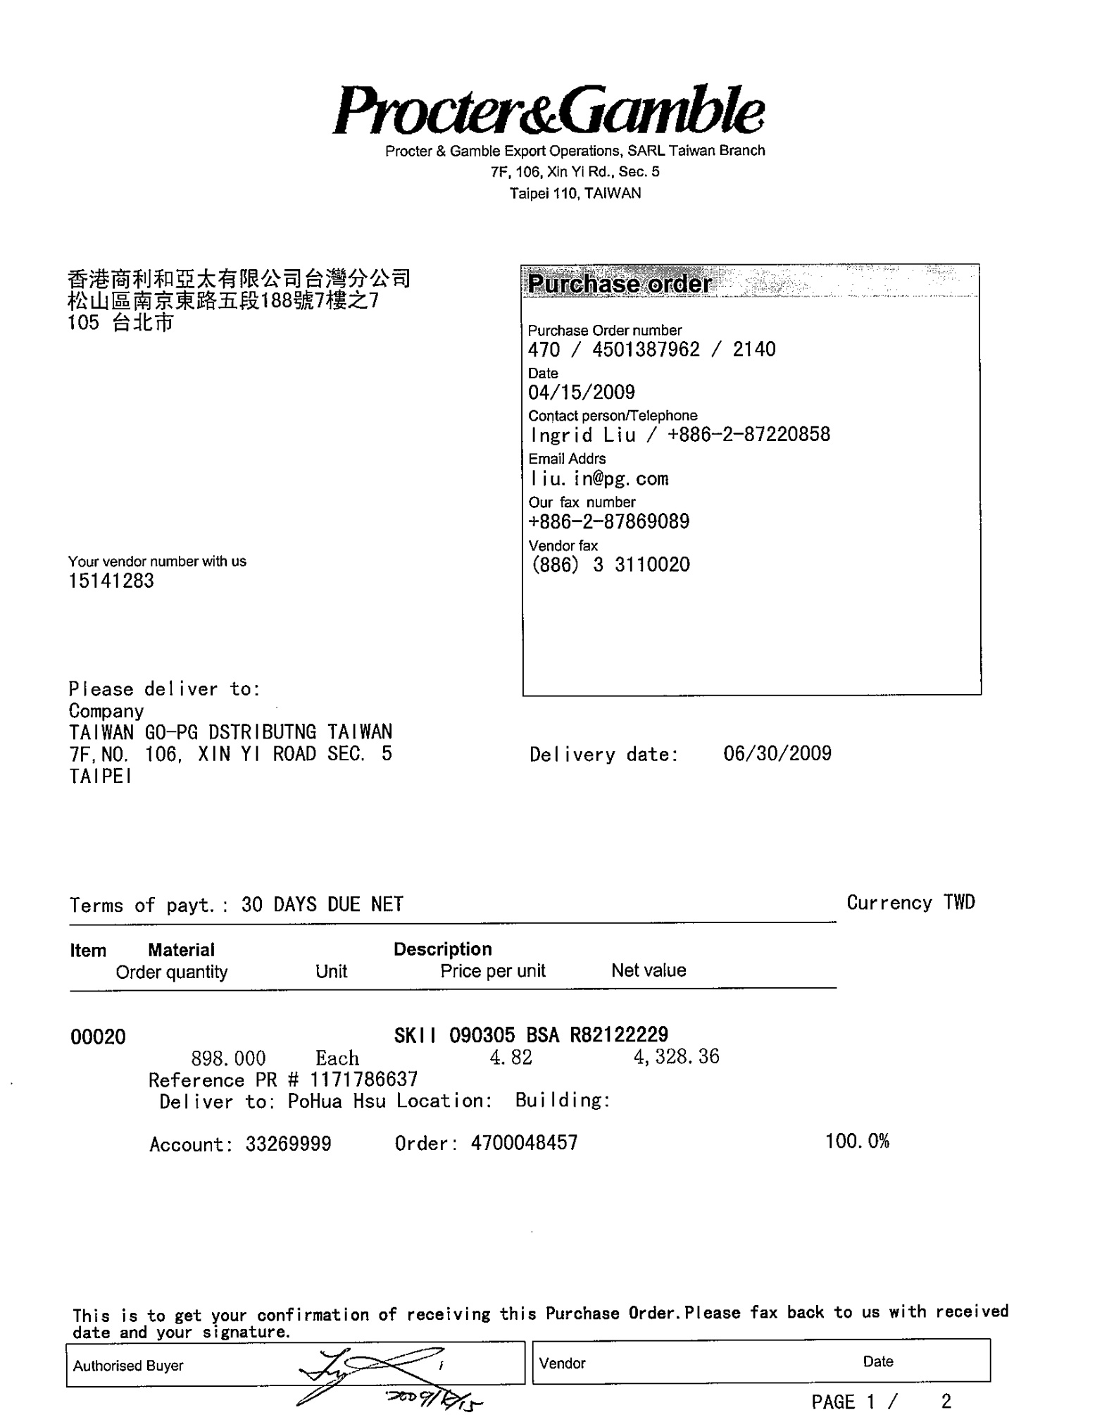

2355

**請確保發票上的名稱與郵寄地址與採購訂單一致**

**採購訂單上的PO號碼470/4501377927/2140**

**(需註明在發票上)**

**廠商簽名確認**

**付款條件**

**供應商名稱及地址**

**第三部份: 發票樣式 Sample of Invoice**

* **需要採購訂單PURCHASE ORDER請款的發票 (with Purchase Order)**

**LE438:**

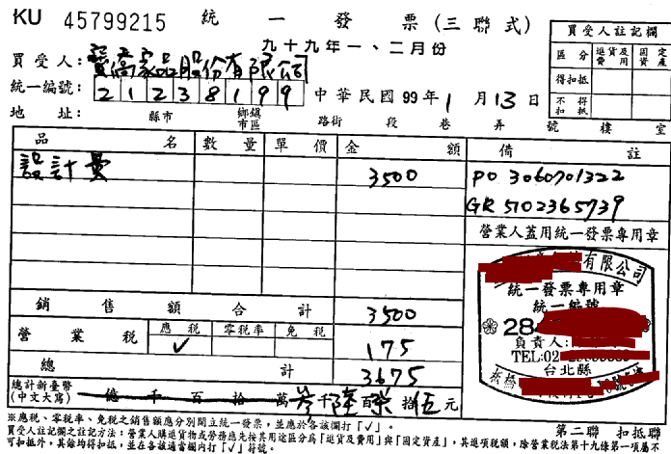

**註明**

**1) 在採購訂單上的PO號碼 (PO no) 470/4501377927/2140;**

**2) 收貨人給的GR收貨號碼 GR# 5002752836**

**(GR no)**

**3) PO line item , description, Q ,Price**

**依採購單方式列明品項/品名/數量/單價**

**發票抬頭及統編**

**LE2355:**

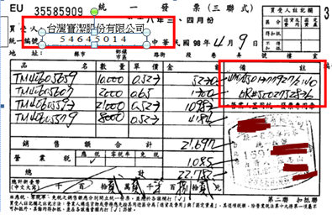

*依據採購單明細列明項目/品名.數量/單價*

**Invoice has match with PO line items and details:**

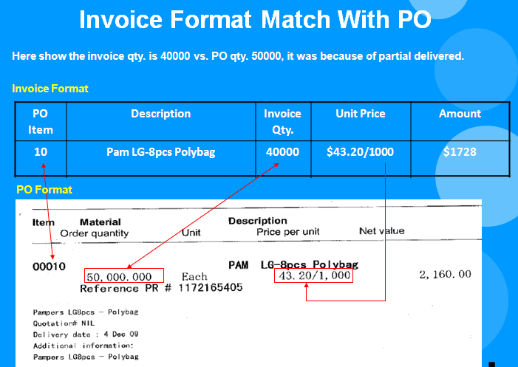

* **不需採購訂單NON-PURCHASE ORDER 請款的發票 (Without Purchase Order)**

**LE438:**

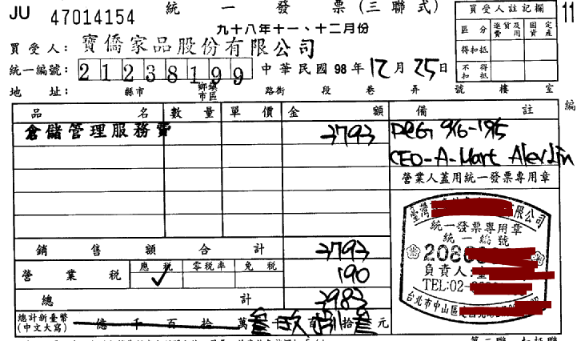

**註明**

1. **寶潔聯絡人originator’s name**
2. **所屬部門**

**Which department**

**發票抬頭及統編**

**LE2355:**

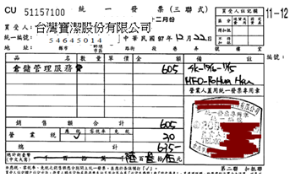

* **Foreign Vendors:**

